PNR: 260740150018
Name: PRATIK SUNIL ABHANG

Set enable password and enable secret password on the router and verify encryption. Also set a console password and access the router from a PC.

1. Topology and Connections
- Router: Cisco 2911
- Switch: Cisco 2960
- PC 1: LAN PC with IP 192.168.10.2
- PC 2: LAN PC with IP 192.168.10.3
- PC 3: Console PC connected to the router Console port with a console cable
- Router-to-switch and switch-to-PC Ethernet links use Copper Straight-Through cables
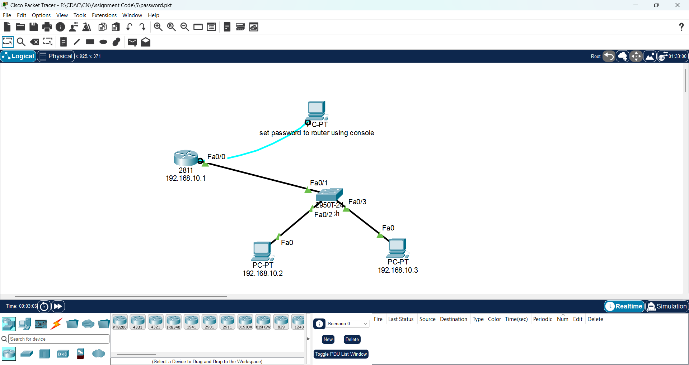

2. Open the Router Through the Console
Use the PC connected to the router with the blue console cable.
PC → Desktop → Terminal → accept the default serial settings → OK.
At the router prompt:
Router> enable
Router# configure terminal

3. Set the Enable Password and Enable Secret
Router(config)# enable password cisco123
Router(config)# enable secret cisco1234
Enable password = cisco123. Enable secret = cisco1234. If both are configured, the enable secret takes precedence when entering privileged EXEC mode.

4. Set the Console Password
Router(config)# line console 0
Router(config-line)# password console123
Router(config-line)# login
Router(config-line)# exit
The login command is required so the console requests the configured password.

5. Configure the Router LAN Interface
Router(config)# interface fastethernet 0/0
Router(config-if)# ip address 192.168.10.1 255.255.255.0
Router(config-if)# no shutdown
Router(config-if)# exit

6. Verify the Password Configuration and Encryption
Router# show running-config
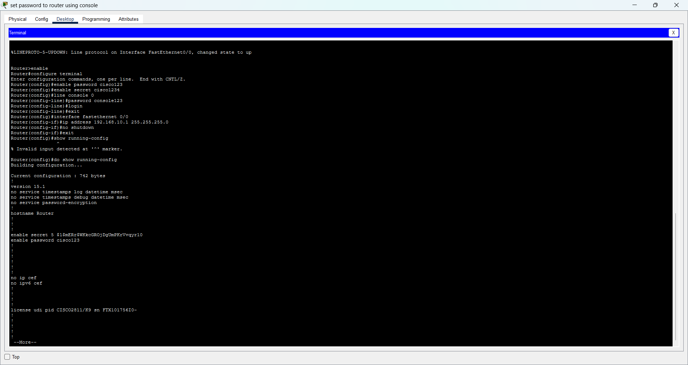

7. Configure the LAN PCs
For PC 1 (the PC labeled 192.168.10.2):
IP Address: 192.168.10.2
Subnet Mask: 255.255.255.0
Default Gateway: 192.168.10.1
For PC 2 (the PC labeled 192.168.10.3):
IP Address: 192.168.10.3
Subnet Mask: 255.255.255.0
Default Gateway: 192.168.10.1

8. Test PC-to-Router Connectivity
From PC 1 or PC 2, open Desktop → Command Prompt and run:
C:\> ping 192.168.10.1
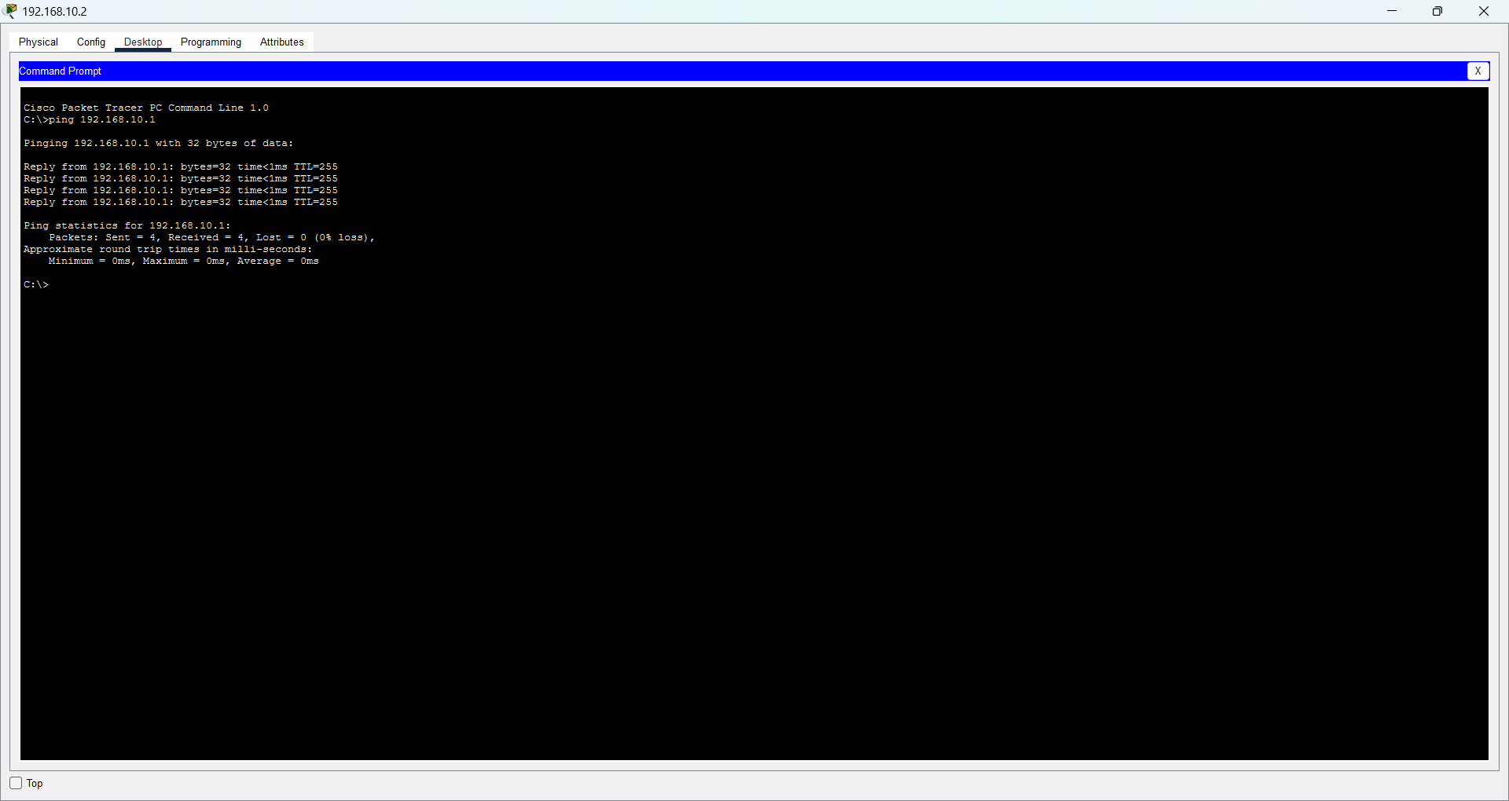

9. Configure Telnet on the Router
Telnet access is configured on the VTY lines:
Router> enable
Router# configure terminal
Router(config)# line vty 0 4
Router(config-line)# password telnet123
Router(config-line)# login
Router(config-line)# transport input telnet
Router(config-line)# exit
Router(config)# end
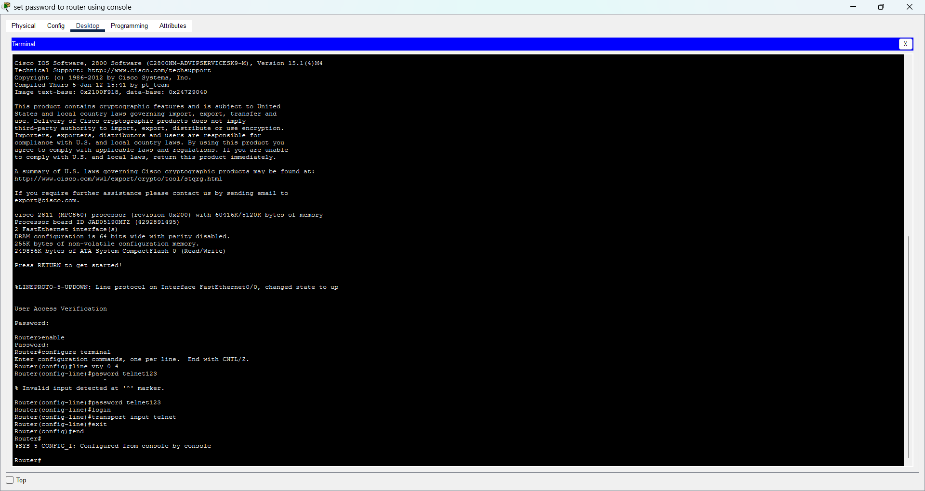

10. Access the Router from a PC Using Telnet
Use PC 1 (192.168.10.2) or PC 2 (192.168.10.3). Open Desktop → Command Prompt.
C:\> telnet 192.168.10.1
Password:
telnet123
Router>

11. Test the Enable Secret Through Telnet
Router> enable
Password:
cisco1234
Router#

12. Final Verification Commands
Router# show running-config
Router# show ip interface brief
